CSCD327 – Lab5

1)

select BOOKS.Title, BOOKS.Retail

from BOOKS

where BOOKS.Retail < (select avg(BOOKS.Retail)

from BOOKS);



2)

select a.Title, b.Category, a.Cost

from BOOKS a, (select BOOKS.Category, avg(BOOKS.Cost) averagecost

from BOOKS

group by BOOKS.Category) b

where a.Category = b.Category

and a.Cost < b.averagecost;

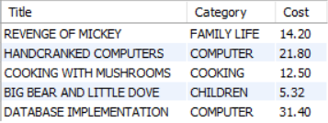

3)

select ORDERS.Order_num

from ORDERS

where ORDERS.ShipState = (select ORDERS.ShipState

from ORDERS

where ORDERS.Order_num = 1014);

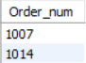

4)

select ORDERITEMS.Order_num, sum(ORDERITEMS.Quantity * ORDERITEMS.PaidEach) as total_order_amount

from ORDERITEMS

group by ORDERITEMS.Order_num

having sum(ORDERITEMS.Quantity * ORDERITEMS.PaidEach) > (select sum(ORDERITEMS.Quantity * ORDERITEMS.PaidEach)

from ORDERITEMS

where ORDERITEMS.Order_num = 1002);

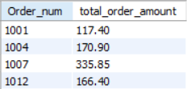

5)

select BOOKS.Title

from BOOKS

where BOOKS.Category in(select distinct BOOKS.Category

from BOOKS join ORDERITEMS using(ISBN)

join ORDERS using(Order_num)

where ORDERS.Customer_num = 1007)

and ISBN not in(select ISBN

from ORDERS join ORDERITEMS using(Order_num)

where ORDERS.Customer_num = 1007);



6)

select ORDERS.ShipCity, ORDERS.ShipState

from ORDERS

where ORDERS.ShipDate - ORDERS.OrderDate = (select MAX(datediff(ORDERS.ShipDate, ORDERS.OrderDate))

from ORDERS);



7)

select CUSTOMERS.Customer_num

from CUSTOMERS join ORDERS using(Customer_num)

join ORDERITEMS using(Order_num)

join BOOKS using(ISBN)

where retail = (select min(retail)

from BOOKS);

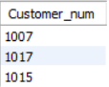

8)

select count(distinct ORDERS.Customer_num)

from ORDERS join ORDERITEMS using(Order_num)

where ISBN in(select ISBN

from ORDERITEMS join BOOKAUTHOR using(ISBN)

join AUTHOR using(Authorid)

where fname = 'JAMES' and lname = 'AUSTIN');



9)

select product_name, list_price

from products

where list_price > (select avg(list_price)

from products

where list_price > 0)

order by list_price desc;



10)

select category_name

from categories

where not exists(select 1

from products p

where p.category_id = categories.category_id);



11)

select email_address, order_id, order_date

from customers T join orders

where order_id = (select min(order_id)

from orders as S

where T.customer_id = S.customer_id);

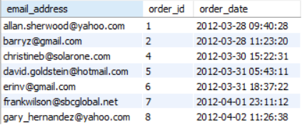

12)

select id, name, salary

from instructor

where salary = (select max(salary)

from instructor);



13)

select id, name, salary

from instructor

where salary = (select max(salary)

from instructor

where salary < (select max(salary)

from instructor));



14)

select id, name, count(distinct course_id) as cnt

from instructor join teaches using(id)

group by id

having

count(distinct course_id) =

(select max(a.num)

from (select count(distinct course_id) as num

from teaches

group by id) as a);

